Advanced Multimedia(Turtle and Arabian Oryx Sanctuary)2220322

*by* 2220322 MANDHR Khalif Salim Almamari

**Submission date:** 27-Apr-2024 10:58PM (UTC+0400)

**Submission ID:** 2363676500

**File name:** Oman_Football_Team2110417.docx

(5.9M)

**Word count:** 2824

**Character count:** 16036

**In academic**

**Affiliation with**

|  |  |  |  |
| --- | --- | --- | --- |
| ***Student name*** | Mandhr Khalif Salim Al-Mamari | | |
| ***ID Number*** | 2220322 | | |
| ***Module Title*** |  | **Advanced Multimedia** |  |
|  |
| ***Program area*** | **CS** | | |
| ***Level*** | 6 | | |
| ***Academic year*** | 2023/2024 | | |
| ***Semester*** | 1 | | |
| ***Assessment*** | **Writ1** | | |
| ***Weighting*** | 50% | | |

Intoduction:

I selected the title "Turtle and Arabian Oryx Sanctuary" because it emphasizes the significant and essential contributions of these two species to Oman's ecosystem. The sanctuary acts as a vital refuge for the endangered Arabian Oryx, representing conservation initiatives in the area, while also underscoring the necessity of safeguarding marine life, especially turtles. This title captures the core of preserving biodiversity and nurturing a greater appreciation for the natural environment, making it a suitable reflection of the themes I aim to investigate in my work.

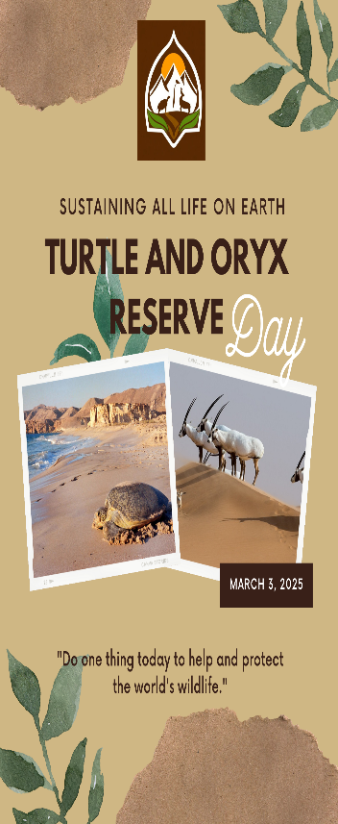 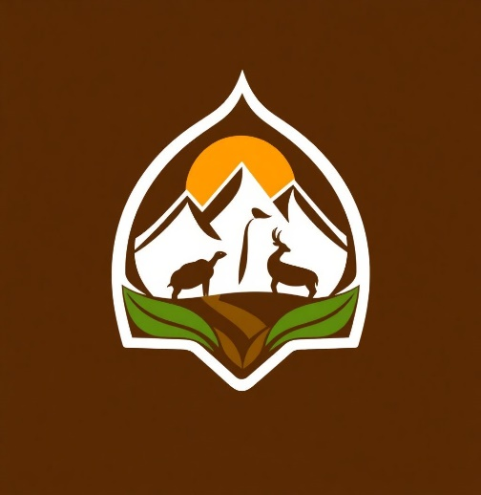

Figure 1.1 logo

Figure 1.2 poster

Logo:

I designed the logo using Arvin, a mobile program that works using artificial intelligence. You just write from your imagination what you want and it creates the logo.‏



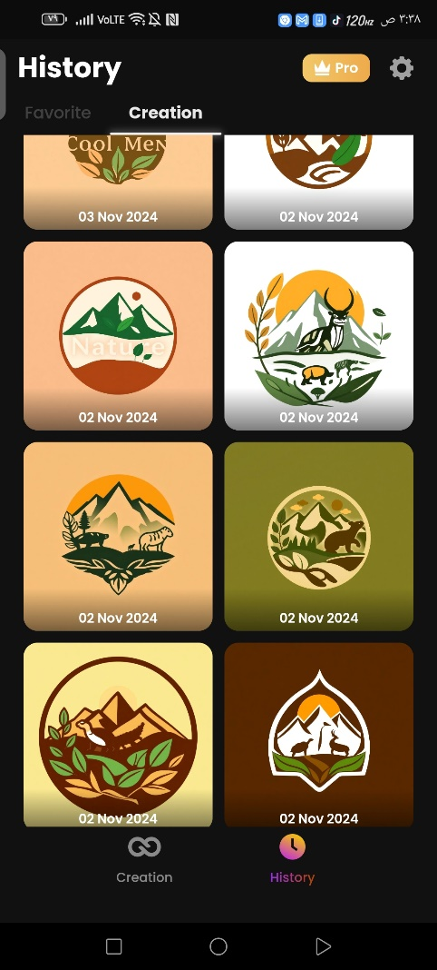 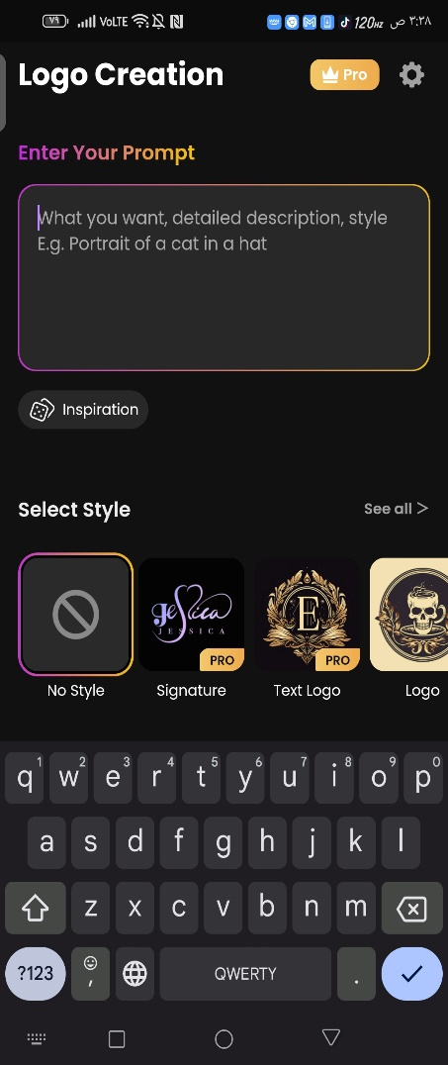

Poster:

I designed the poster using Canva. I went to the poster option, then chose the appropriate design, then put the pictures I wanted, and after that I changed the written text so that I put phrases related to the topic I was talking about.

‏

Still Image:

a stunning image of the Turtle Sanctuary and Arabian Oryx Sanctuary, highlighting the peaceful coexistence of desert and marine ecosystems. In this picture, you would observe the graceful Arabian Oryx navigating the arid terrain, representing strength and elegance, while the serene turtles head towards the glistening ocean, forming a harmonious fusion of two unique habitats. It's a captivating scene that embodies the essence of nature’s harmony and variet.

Orginal images:

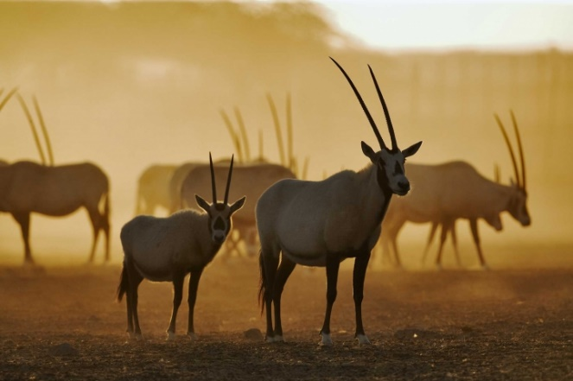 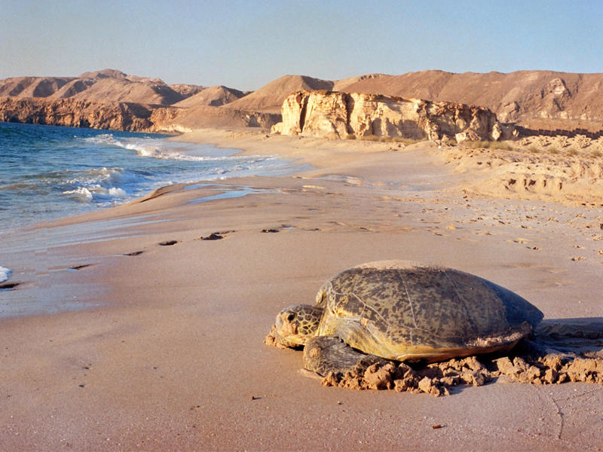

Figure 1: Orginal image2

Figure 1: Orginal image1

There are Original images picked from internet

Canva editing:

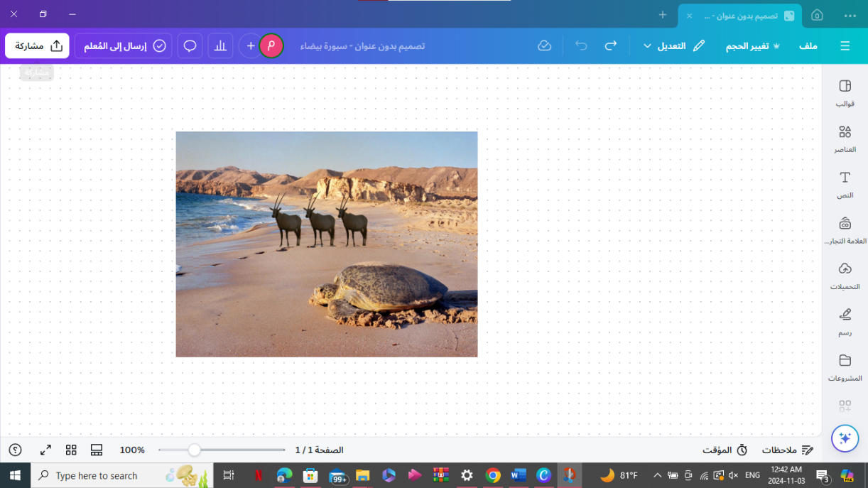

I removed the background of the Arabian oryx image, then took the oryx alone and placed it in the background of the turtle image. After that, I placed the reflection on the oryx as if it were walking towards the sea. Finally, I repeated this to show me more than one oryx.‏

Image after modification:

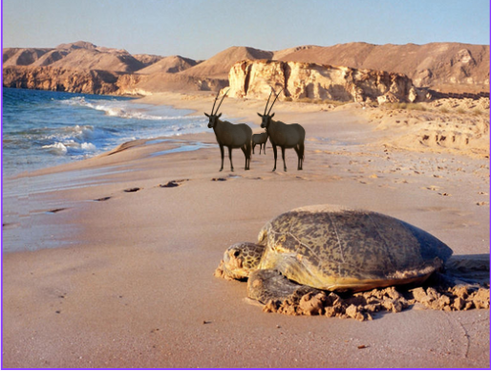

Orginal images:

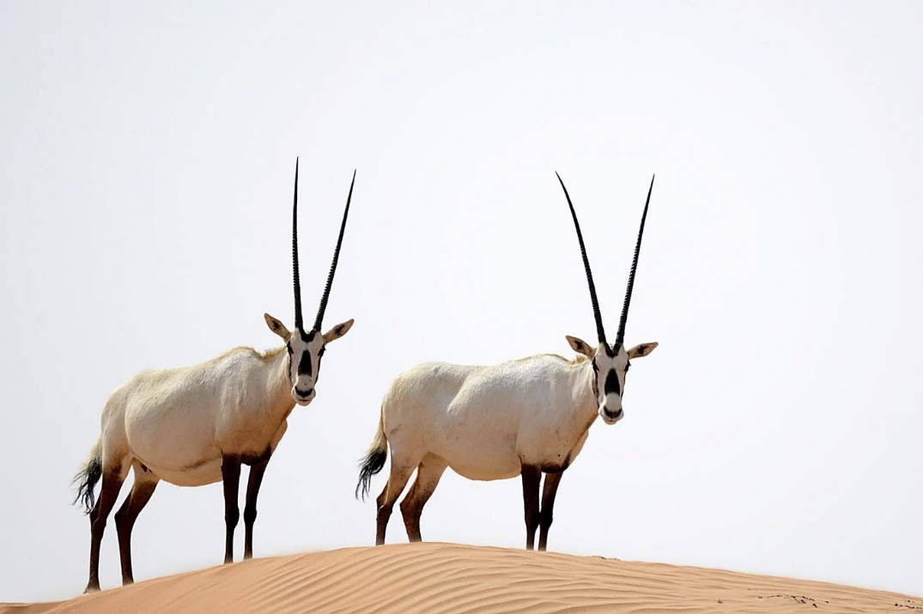

Orginal picture of two Arabian oryx in the desert

Canva editing:

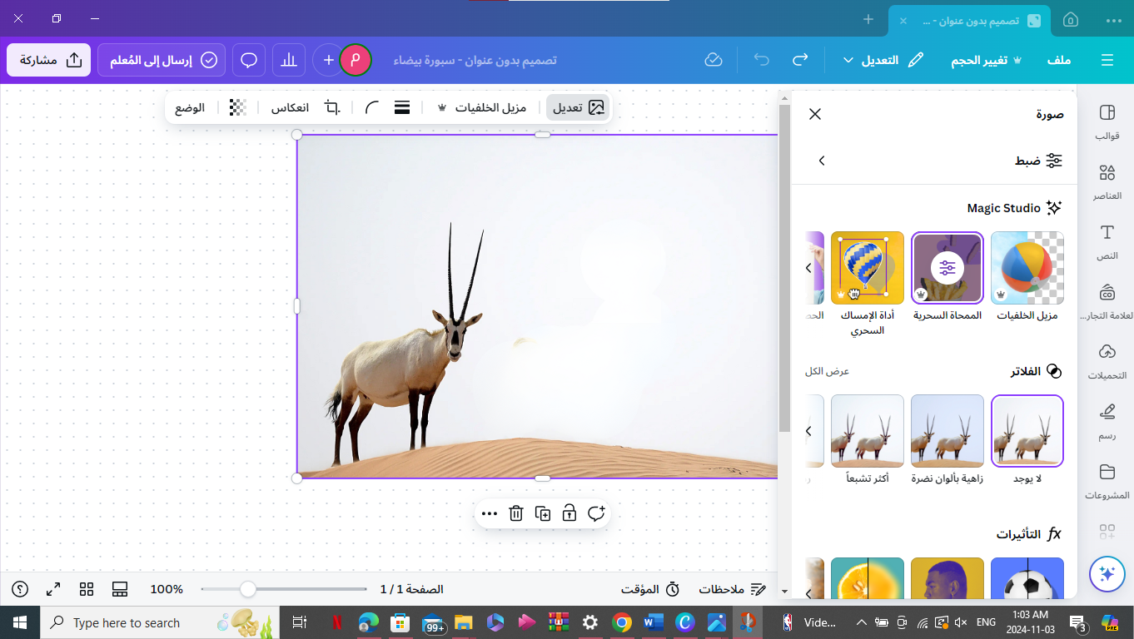

I removed one of the oryx with the magic eraser that simulates artificial intelligence as if the picture had only one Arabian oryx in it.‏

Element remove photo: 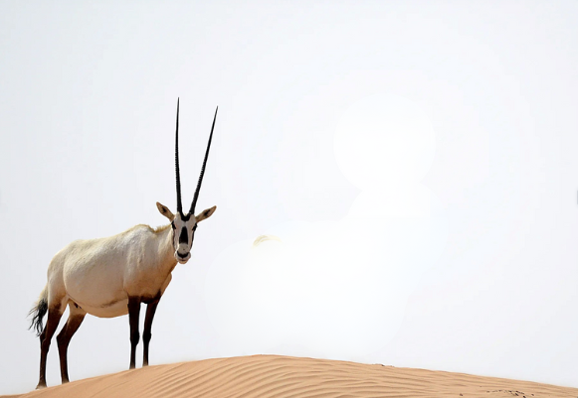

Orginal images:

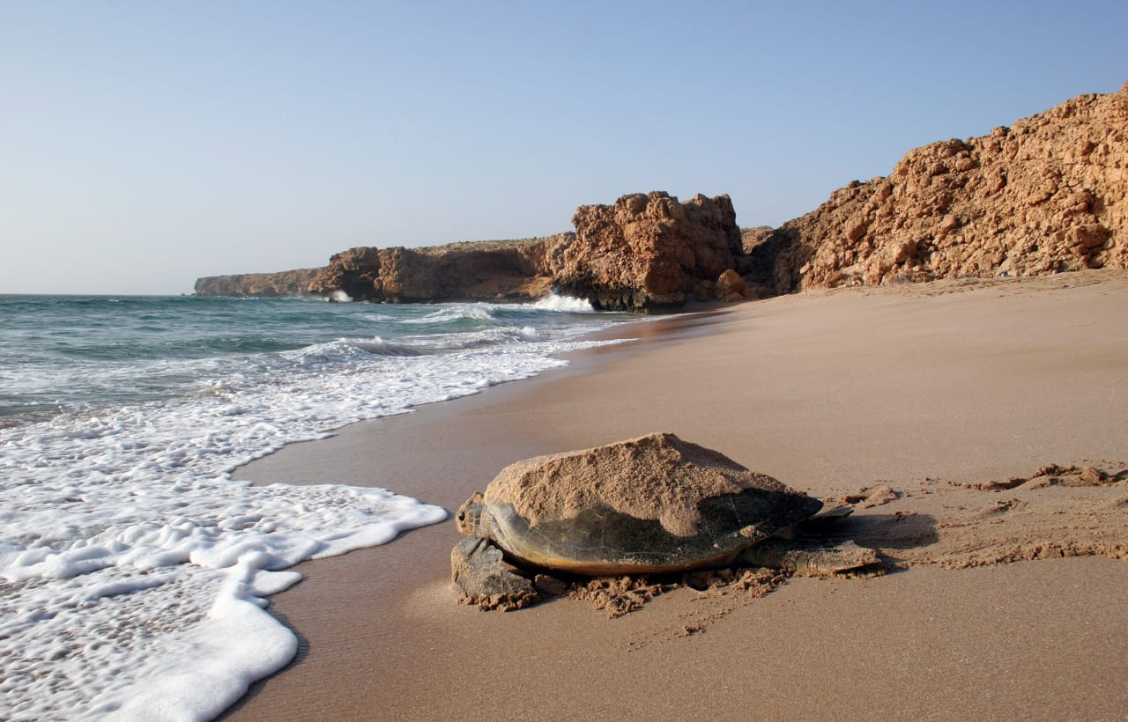

Orginal photo of a turtle on the beach going to the sea after laying its eggs.

Canva editing:

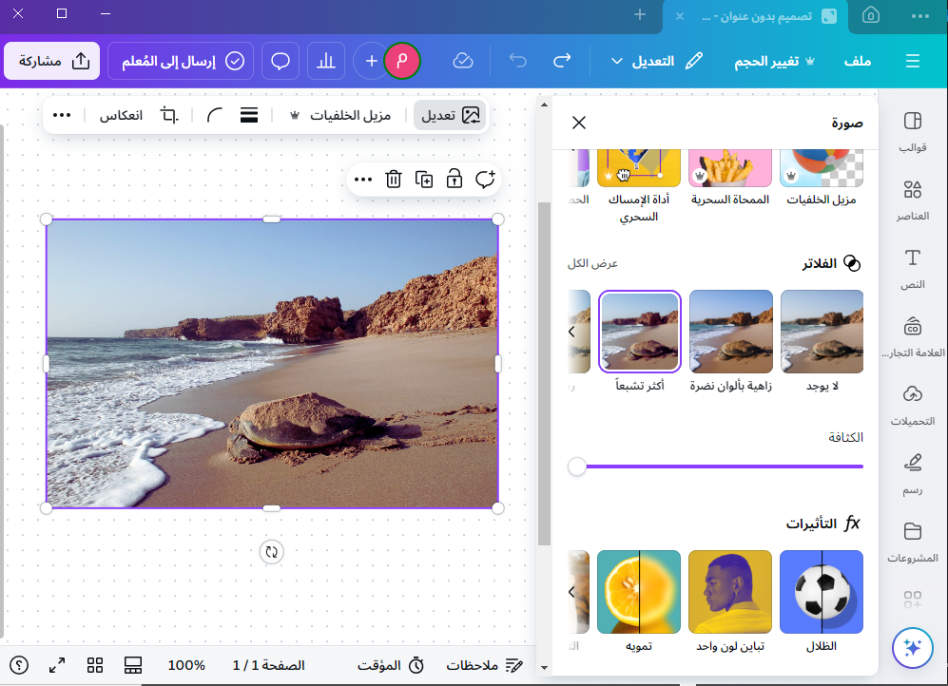

I adjusted the clarity of the image using filters, choosing the appropriate filter, which is the most saturated, to purify the image with all its details. I choose Sharpen Filters: These increase the clarity of details, making the image appear crisper.

Correction of exposure:

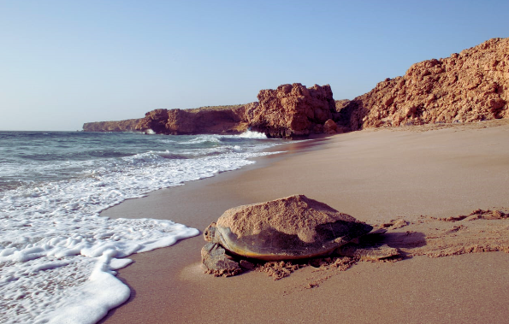

Orginal images:



It is Original image picked from internet.

Canva editing:

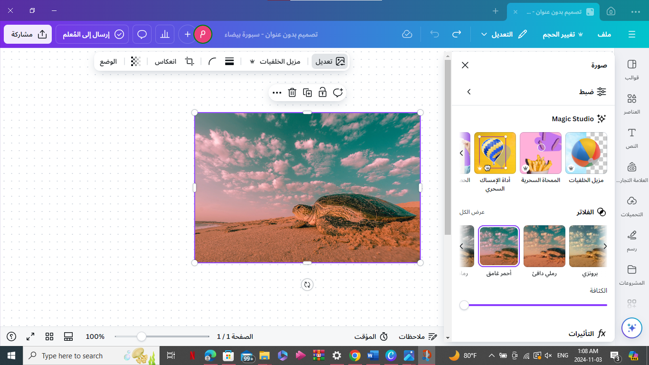

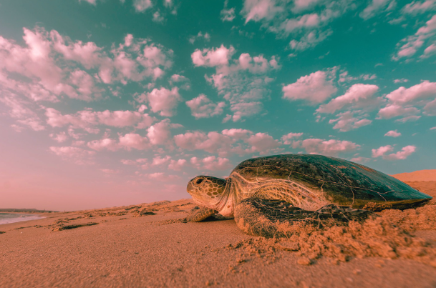

A filter is a tool used to apply specific effects to an image, helping to enhance or alter its appearance. There are various types of filters. I choose Blur Filters: These are used to soften details in the image, creating a smooth effect.

tab view image: ‏

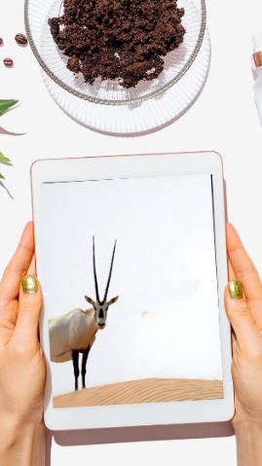

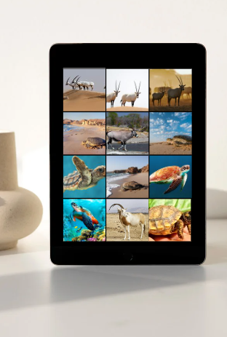

mobile phone view image:

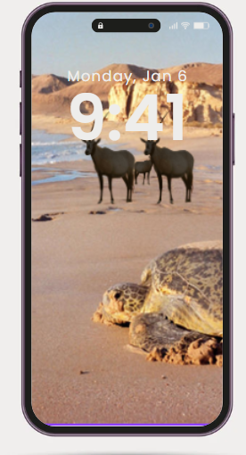

laptob view image:



Orginal images:

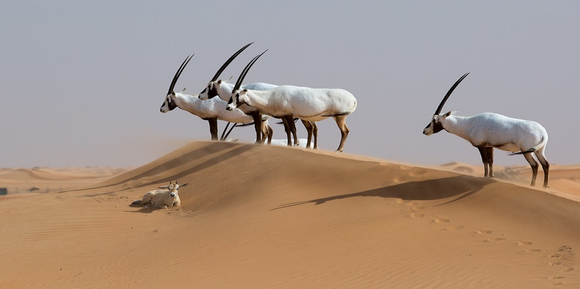

Canva editing:

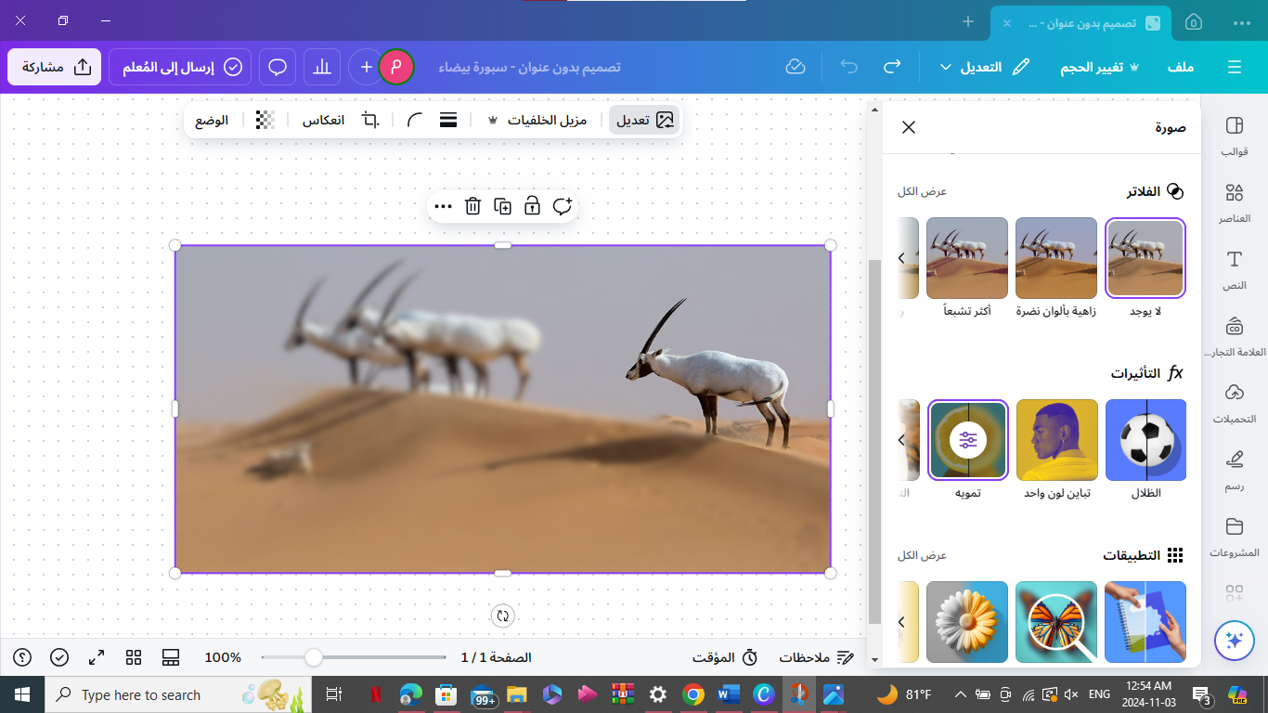

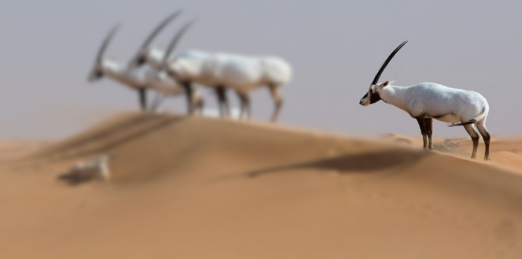

In this image I have added camouflage to the desert sand and a group of oryx and put the focus on one Arabian oryx. This camouflage makes the viewer focus on the scene that the designer wanted.

Moving picture(video): ‏

A moving picture, or video, serves as an enchanted doorway to another world. Videos can be used to capture the beauty of the natural world, the energy of a bustling marketplace, or the joy of a celebration. It's amazing how powerful emotions and gripping stories can be evoked by a series of moving images and sound. Videos bring people together in a special way and make it possible to share experiences in a dynamic and engaging way.

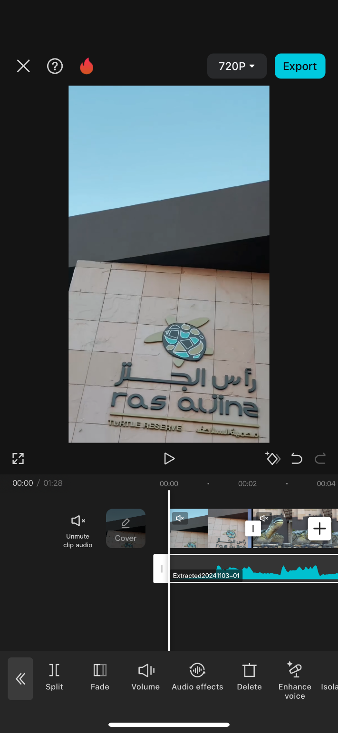

Here I edited the video using a mobile phone program called CapCut, and here I put the music and reduced the volume.‏

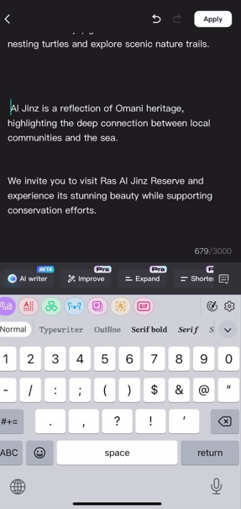

Here I put the appropriate writing in the clip and in the program I can simulate the writing with the voice and there are many voices I can choose a character to perform the voice.‏

click here to see the oryx video:

<https://youtube.com/shorts/UdHWvwsbq84?si=4RlqiJAC2DTzeRr->

click here to see the turtle video:

<https://youtube.com/shorts/1ZADyYq1JQE?si=3DIkEz--piDCYJuX>

**Audio:**

Audio refers to sound that has been recorded, transmitted, or played back. It includes a broad spectrum of frequencies discernible by the human ear, usually ranging from 20 Hz to 20 kHz. Audio can take on various forms, such as music, spoken language, and sound effects, and is frequently utilized in mediums like films, music recordings, and podcasts. From a technical perspective, audio can be categorized as analog or digital. Analog audio is depicted by continuous sound waves, whereas digital audio is characterized by discrete values, which facilitate easier manipulation and storage on devices like computers and smartphones.

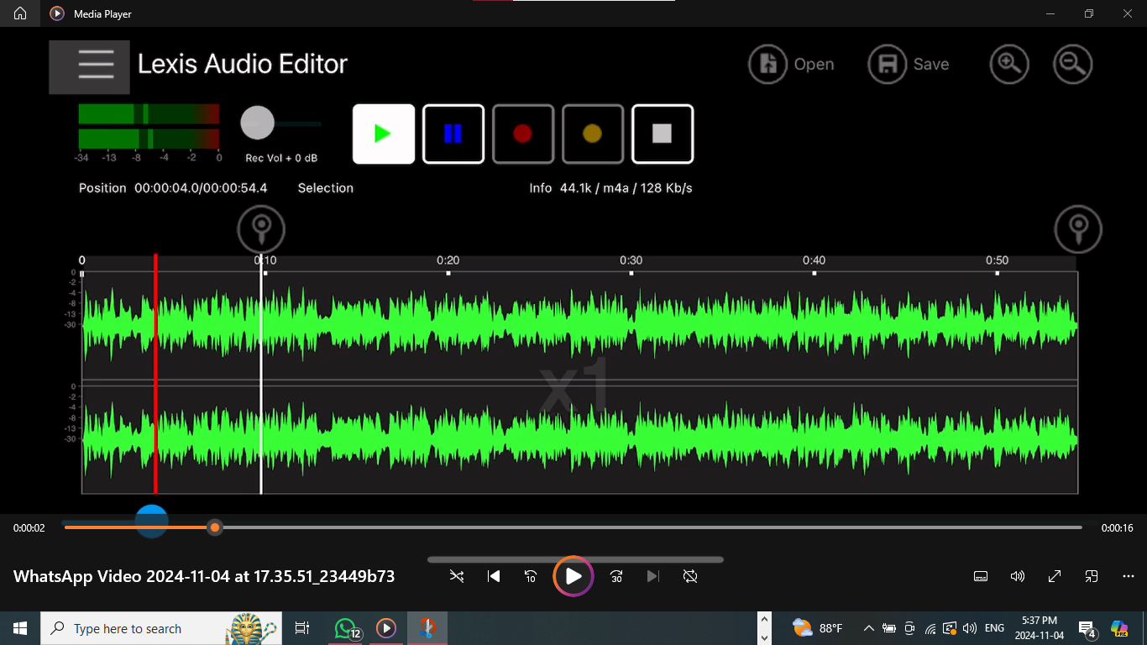

I edited the sound on a mobile program called Lexis Audio Editor, which is a sound effects mode like music with a person speaking.‏

3D

Utilizing 3D technology feels like stepping into an entirely different dimension of innovation and artistic expression. It adds depth and realism to images, making them feel almost tangible. With 3D, you can venture into virtual environments, embark on thrilling journeys, and witness breathtaking landscapes as if you were really present. It's truly fascinating how these three-dimensional visuals leap out and captivate you. It's incredible how advancements in technology can transform our viewing and create a more engaging and vibrant experience.

Paint 3D:

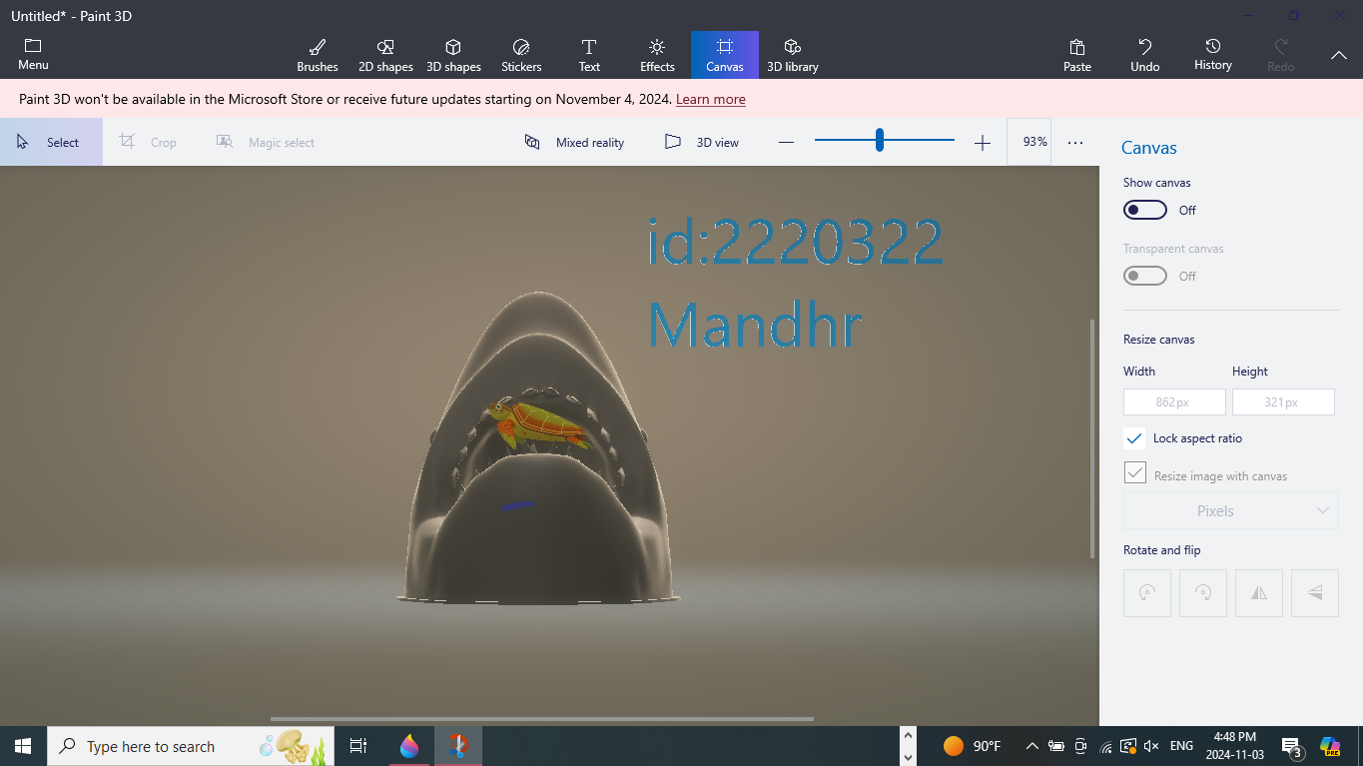

I added the turtle inside the shark's mouth as if it was eating it. Then I removed the white background and added the text containing my university number and name. Finally, I saved it as an mp4 video clip. I uploaded the clip to YouTube.‏

From here you can watch the 3D video

<https://youtu.be/fbzMWxCGxAw>

**Home page:**

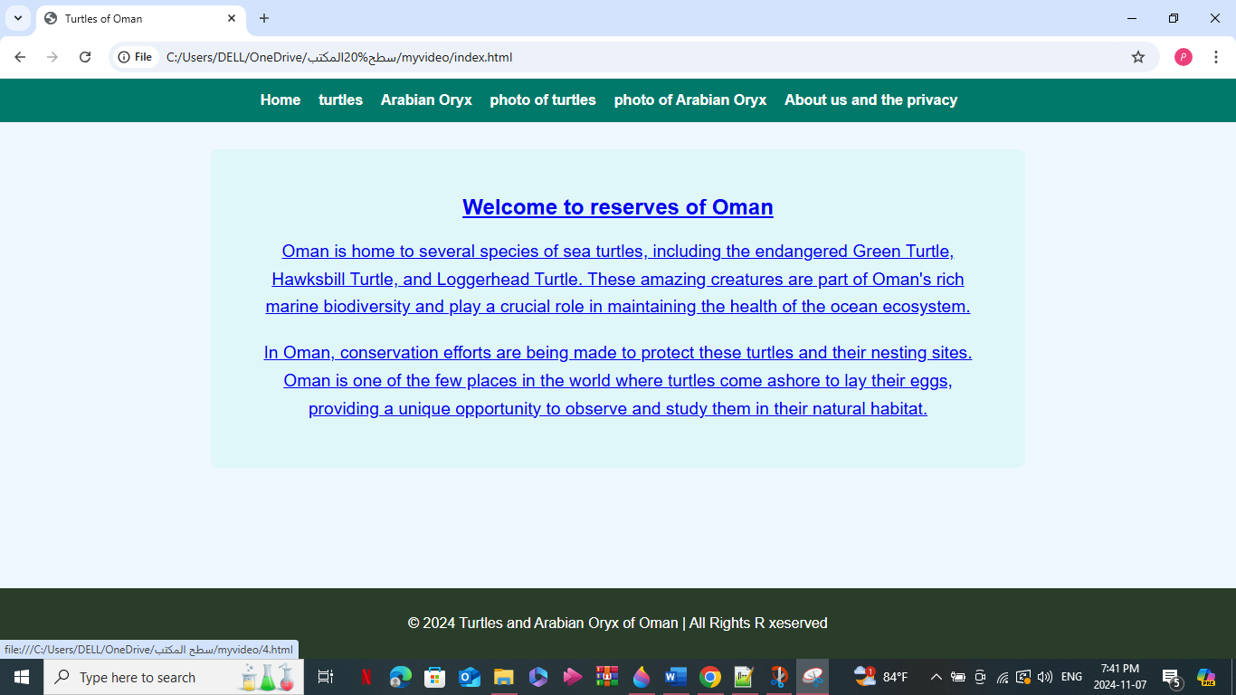

This is the page that a visitor sees when he enters this site. This page is considered the main interface and contains information about the importance of wildlife and the importance of preserving it to maintain the environmental balance. The bar at the top contains the site's pages, and through it you can navigate between the pages. The bar at the bottom is to display the site name and calendar year.

**Code:**

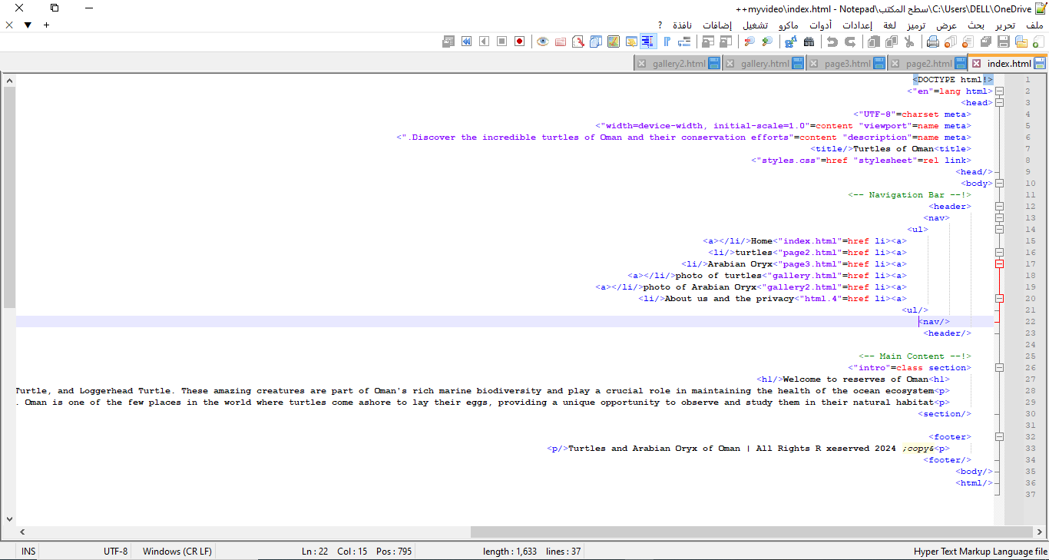

**Other pages:**

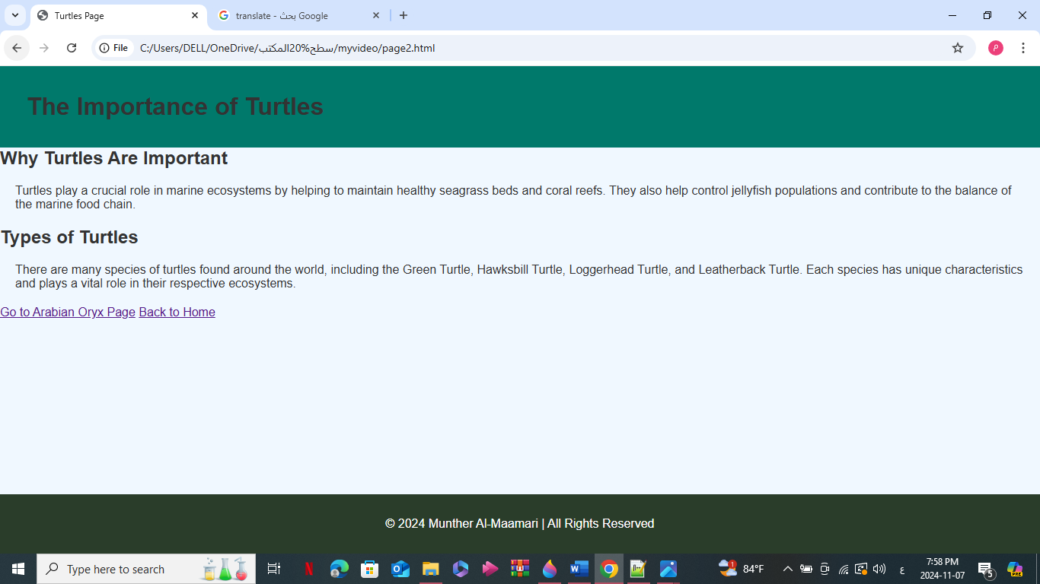

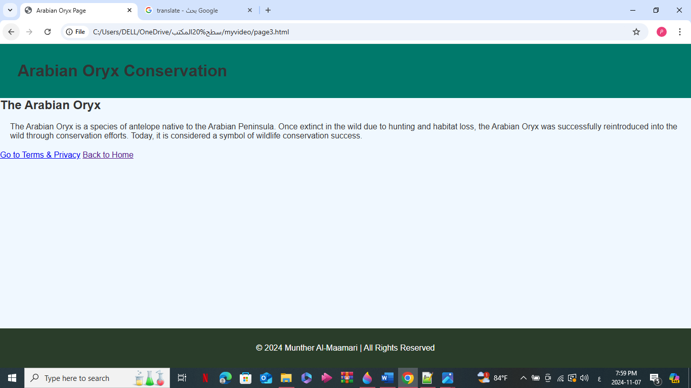

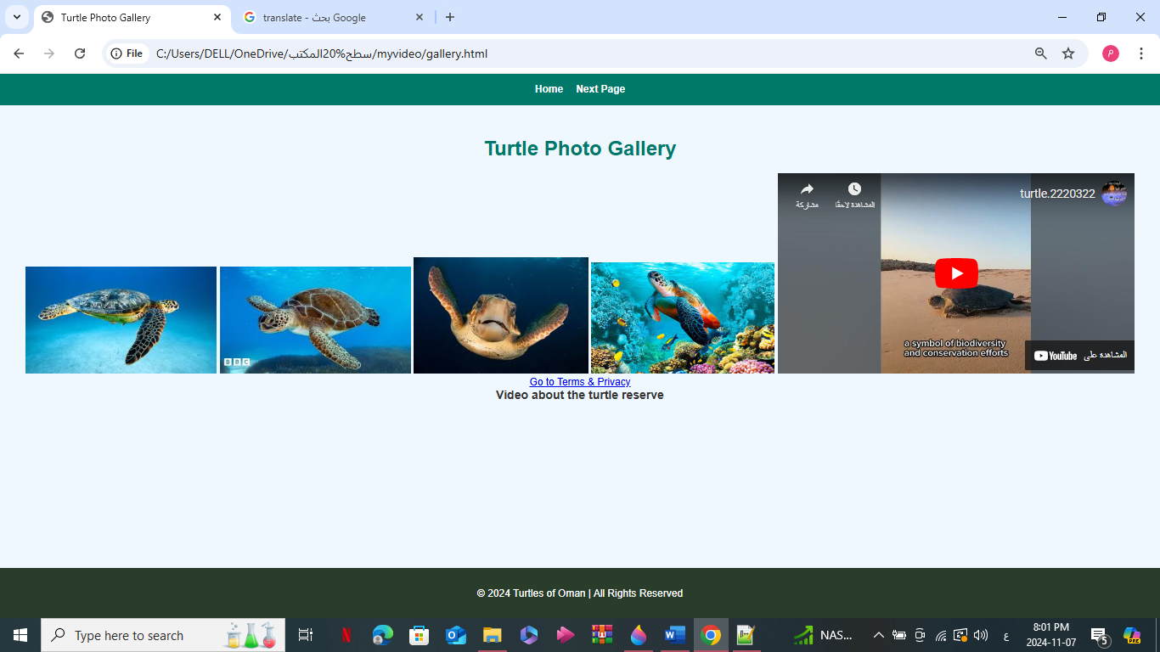

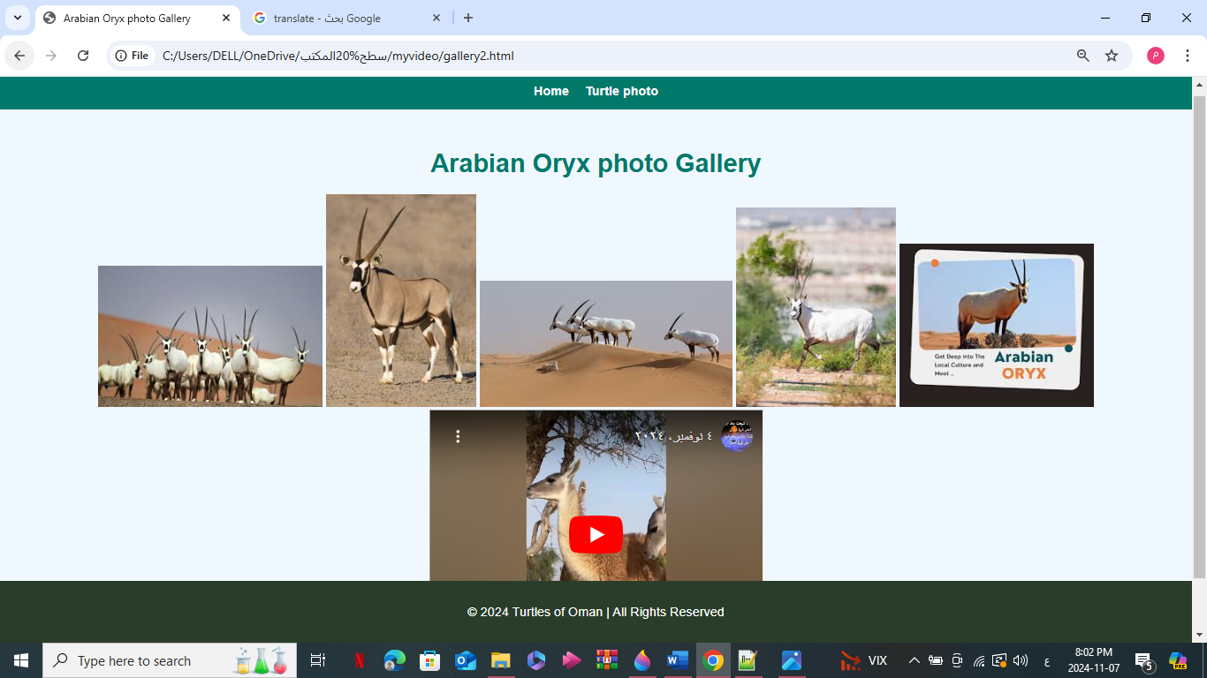

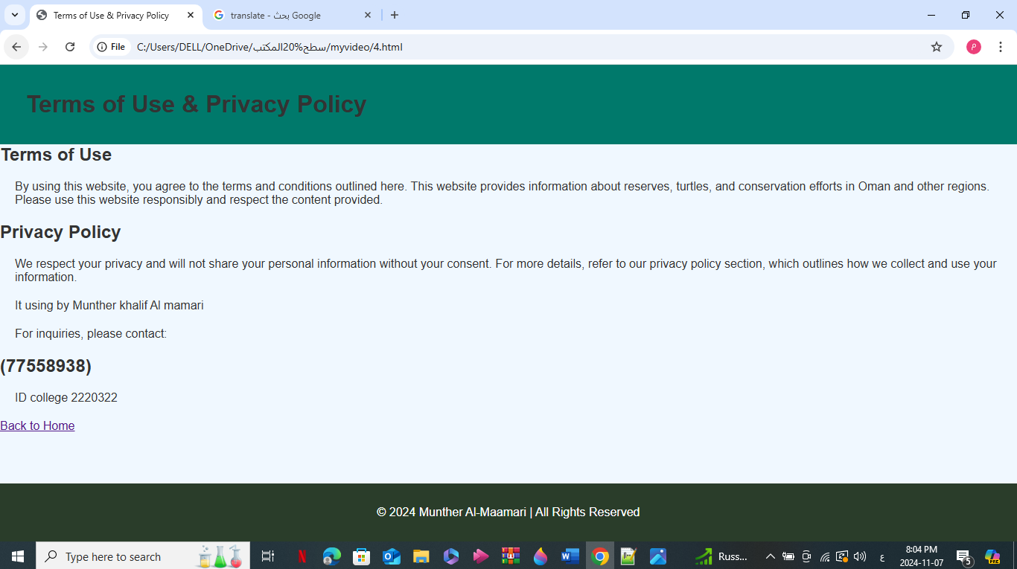

**Codes:**

**Page 1:**

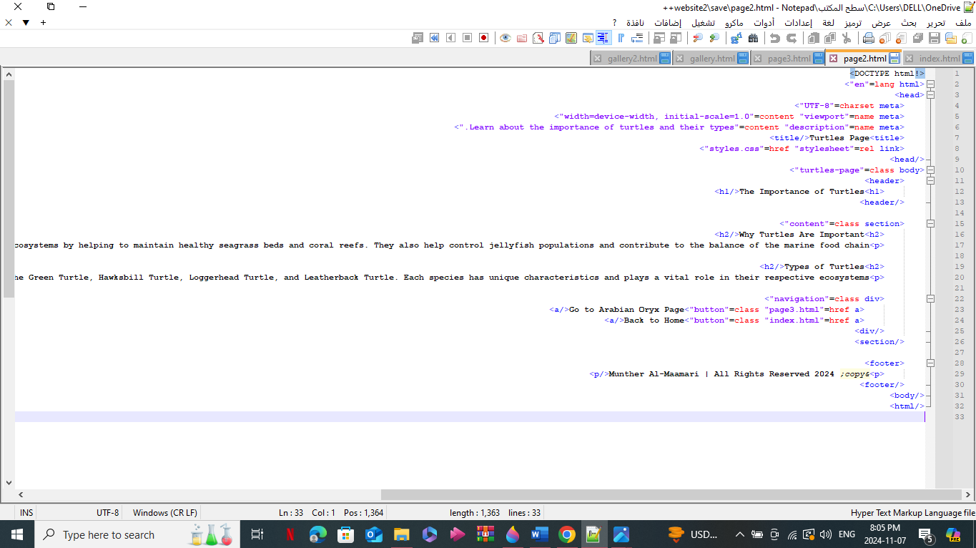

**Page 2:**

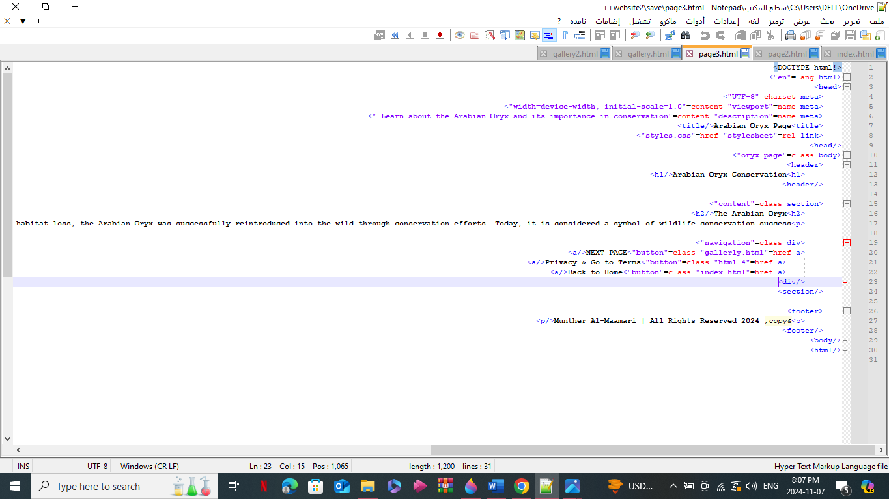

**Photo and youtube video of turtles code:**

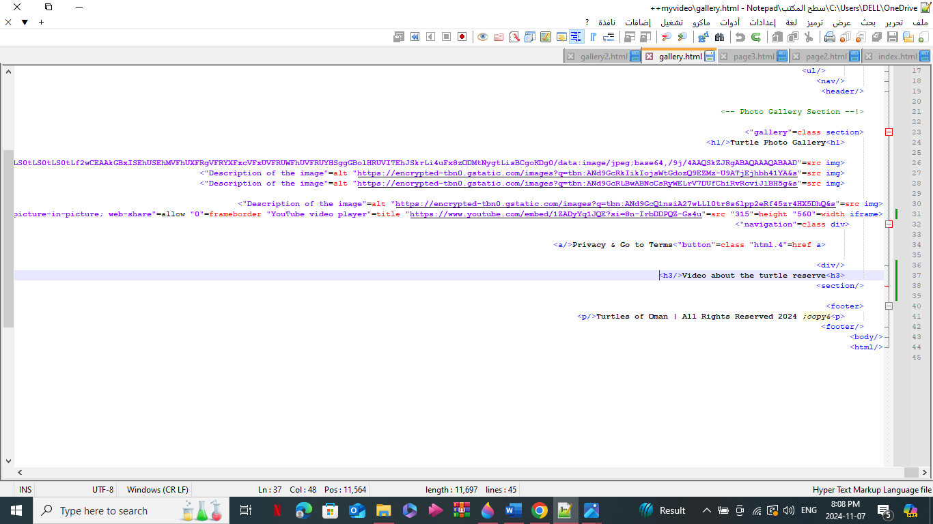

**Photo and youtube video of Arabian oryx code:**



